**Project Design Phase**

**Solution Architecture**

|  |  |
| --- | --- |
| Date | 14 June 2025 |
| Team ID | LTVIP2025TMID60746 |
| Project Name | Sustainable Smart City Assistant Using IBM Granite LLM |
| Maximum Marks | 4 Marks |

**Solution Architecture:**

Solution architecture is the plan for how our smart city assistant works.

#### ****What it does:****

* Chooses the right technology to solve city problems.
* Explains how the system works to everyone involved.
* Lists the features and steps to build the assistant.
* Gives clear rules to build and manage the project.

It helps us build a smart, useful, and easy-to-use assistant using **IBM Granite LLM**.

**Example - Solution Architecture Diagram:**

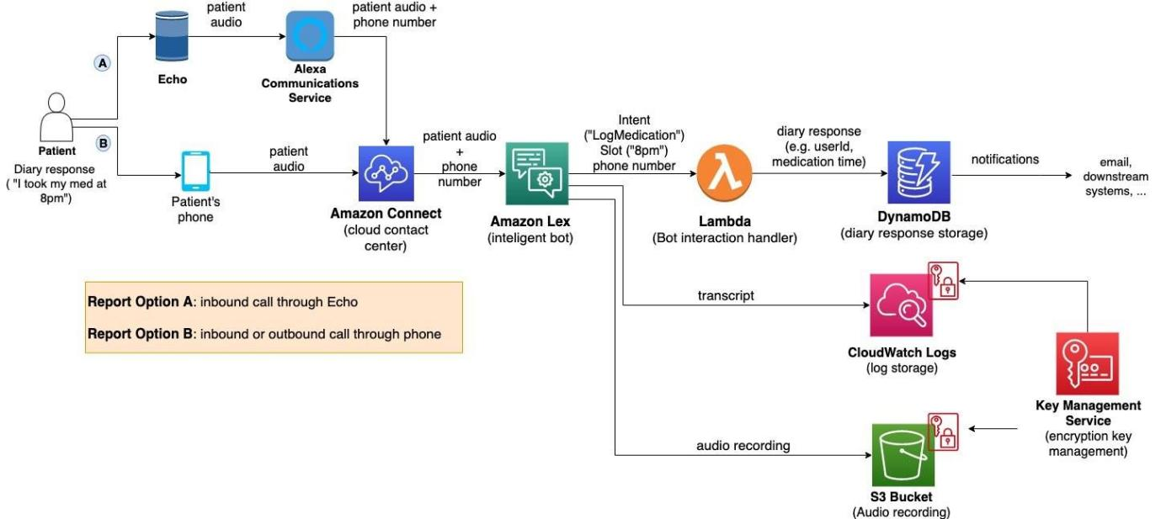

*Figure 1: Architecture and data flow of the voice patient diary sample application*